# **Setting up developer environment**

## **Introduction**

This document provides a comprehensive guide to setting up a developer environment on Windows 11 using Visual Studio Code, Git, Python, and MySQL.

## **Steps**

1. Install Windows 11 - Download the installer from (<https://www.microsoft.com/software-download/windows11>).

- Create a bootable USB drive and follow the on-screen instructions

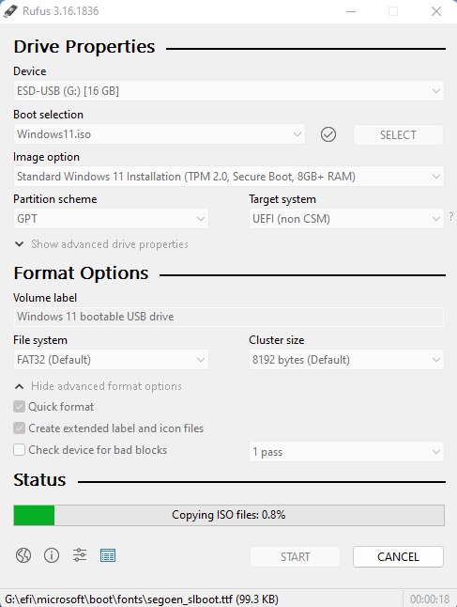

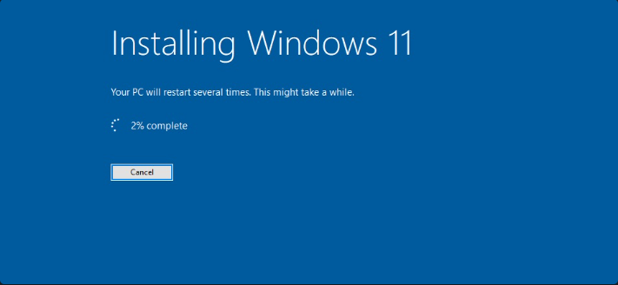

1. Install Visual Studio Code - Download the installer from (https://code.visualstudio.com/Download). - Follow the setup wizard to install.

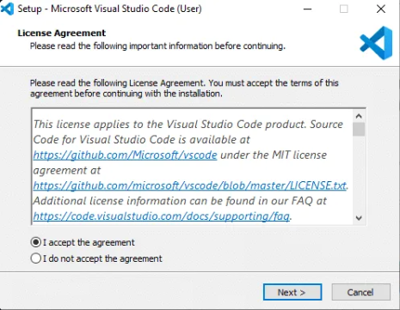

1. Set Up Git - Download Git from (<https://git-scm.com/download/win>). **configure it on your local machine. Create a GitHub account for hosting your repositories.**
   * Visit the [Git download page](https://git-scm.com/download/win).
   * Download the Git installer and run it.
   * Follow the installation steps and choose the default options.

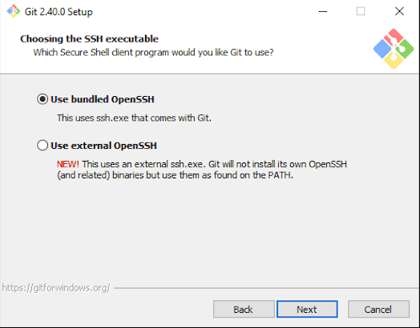

- Configure Git with your name and email:

>>> git config --global user.name "Username"

>>> git config --global user.email “[email@example.com](mailto:email@example.com)”

1. Installation of python

* Visit the [Python download page](https://www.python.org/downloads/).
* Download the installer for Windows and run it.
* Ensure you check the "Add Python to PATH" option during installation.
* Verify the installation, open command prompt and type below command:

>>> python –version

1. Configure a Database (MySQL)

**Download and Install MySQL:**

* + Visit the [MySQL download page](https://dev.mysql.com/downloads/windows/installer/5.7.html).
  + Download the MySQL Installer and run it.
  + Follow the installation steps to set up MySQL on your machine.

1. A public repository containing the project

https://github.com/EmanuelSolver/first-plp-repo/tree/main